Lab/System/Asset Utilization Monitoring Example
Overview:
This example project provides all required resources to configure and execute a Lab/System/Asset Utilization workflow example. It includes a Jupyter Notebook and instructions for implementing a scheduled routine for data processing and three Grafana dashboards, each designed to visualize utilization metrics at distinct hierarchical levels.
Solution Overview:
To deliver comprehensive visualization, this architecture leverages three Grafana dashboards that utilize built-in data sources, eliminating the need for custom coding. System-level and asset-level utilization data is collected at the SystemLink client layer, automatically transmitted to SystemLink, and made accessible through standard APIs. The example project includes a preconfigured Jupyter Notebook that processes raw utilization history, generates initial tags, and subsequently appends new utilization values upon each execution. This approach ensures that every system and asset is associated with utilization-specific tags, enabling straightforward visualization through Grafana dashboards using out-of-the-box data sources.
After importing the dashboard into SystemLink, the following predefined dashboards become available. Each dashboard implements a hierarchical drill-down approach and includes dropdown selectors for Labs, Systems, and Assets. The dashboards present high-level utilization metrics along with two time-series charts that display utilization trends for the selected timeframe across two default categories: Test and Configuration.

- Lab Utilization Dashboard
  - Lab-level utilization is derived from the aggregate utilization of all systems grouped within a single workspace. To enable tracking at the Lab level, systems must be organized into workspaces and mapped to their corresponding physical Lab.

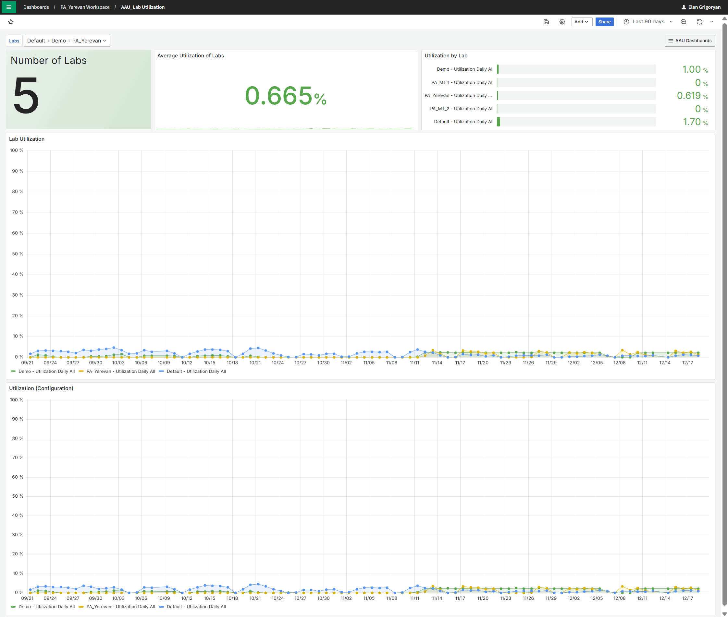
- System Utilization
  - When the System Utilization dashboard is opened, users can select the desired Lab to locate a specific system for utilization analysis. These selectors are positioned in the upper section of the dashboard.
  - The drill-down view provides detailed insights, including the total number of systems within the selected Lab or workspace, their connection status, and system-level details presented in a tabular format.
  - All dashboards share a consistent UI layout and include two time-series charts that display utilization metrics for each predefined utilization category.
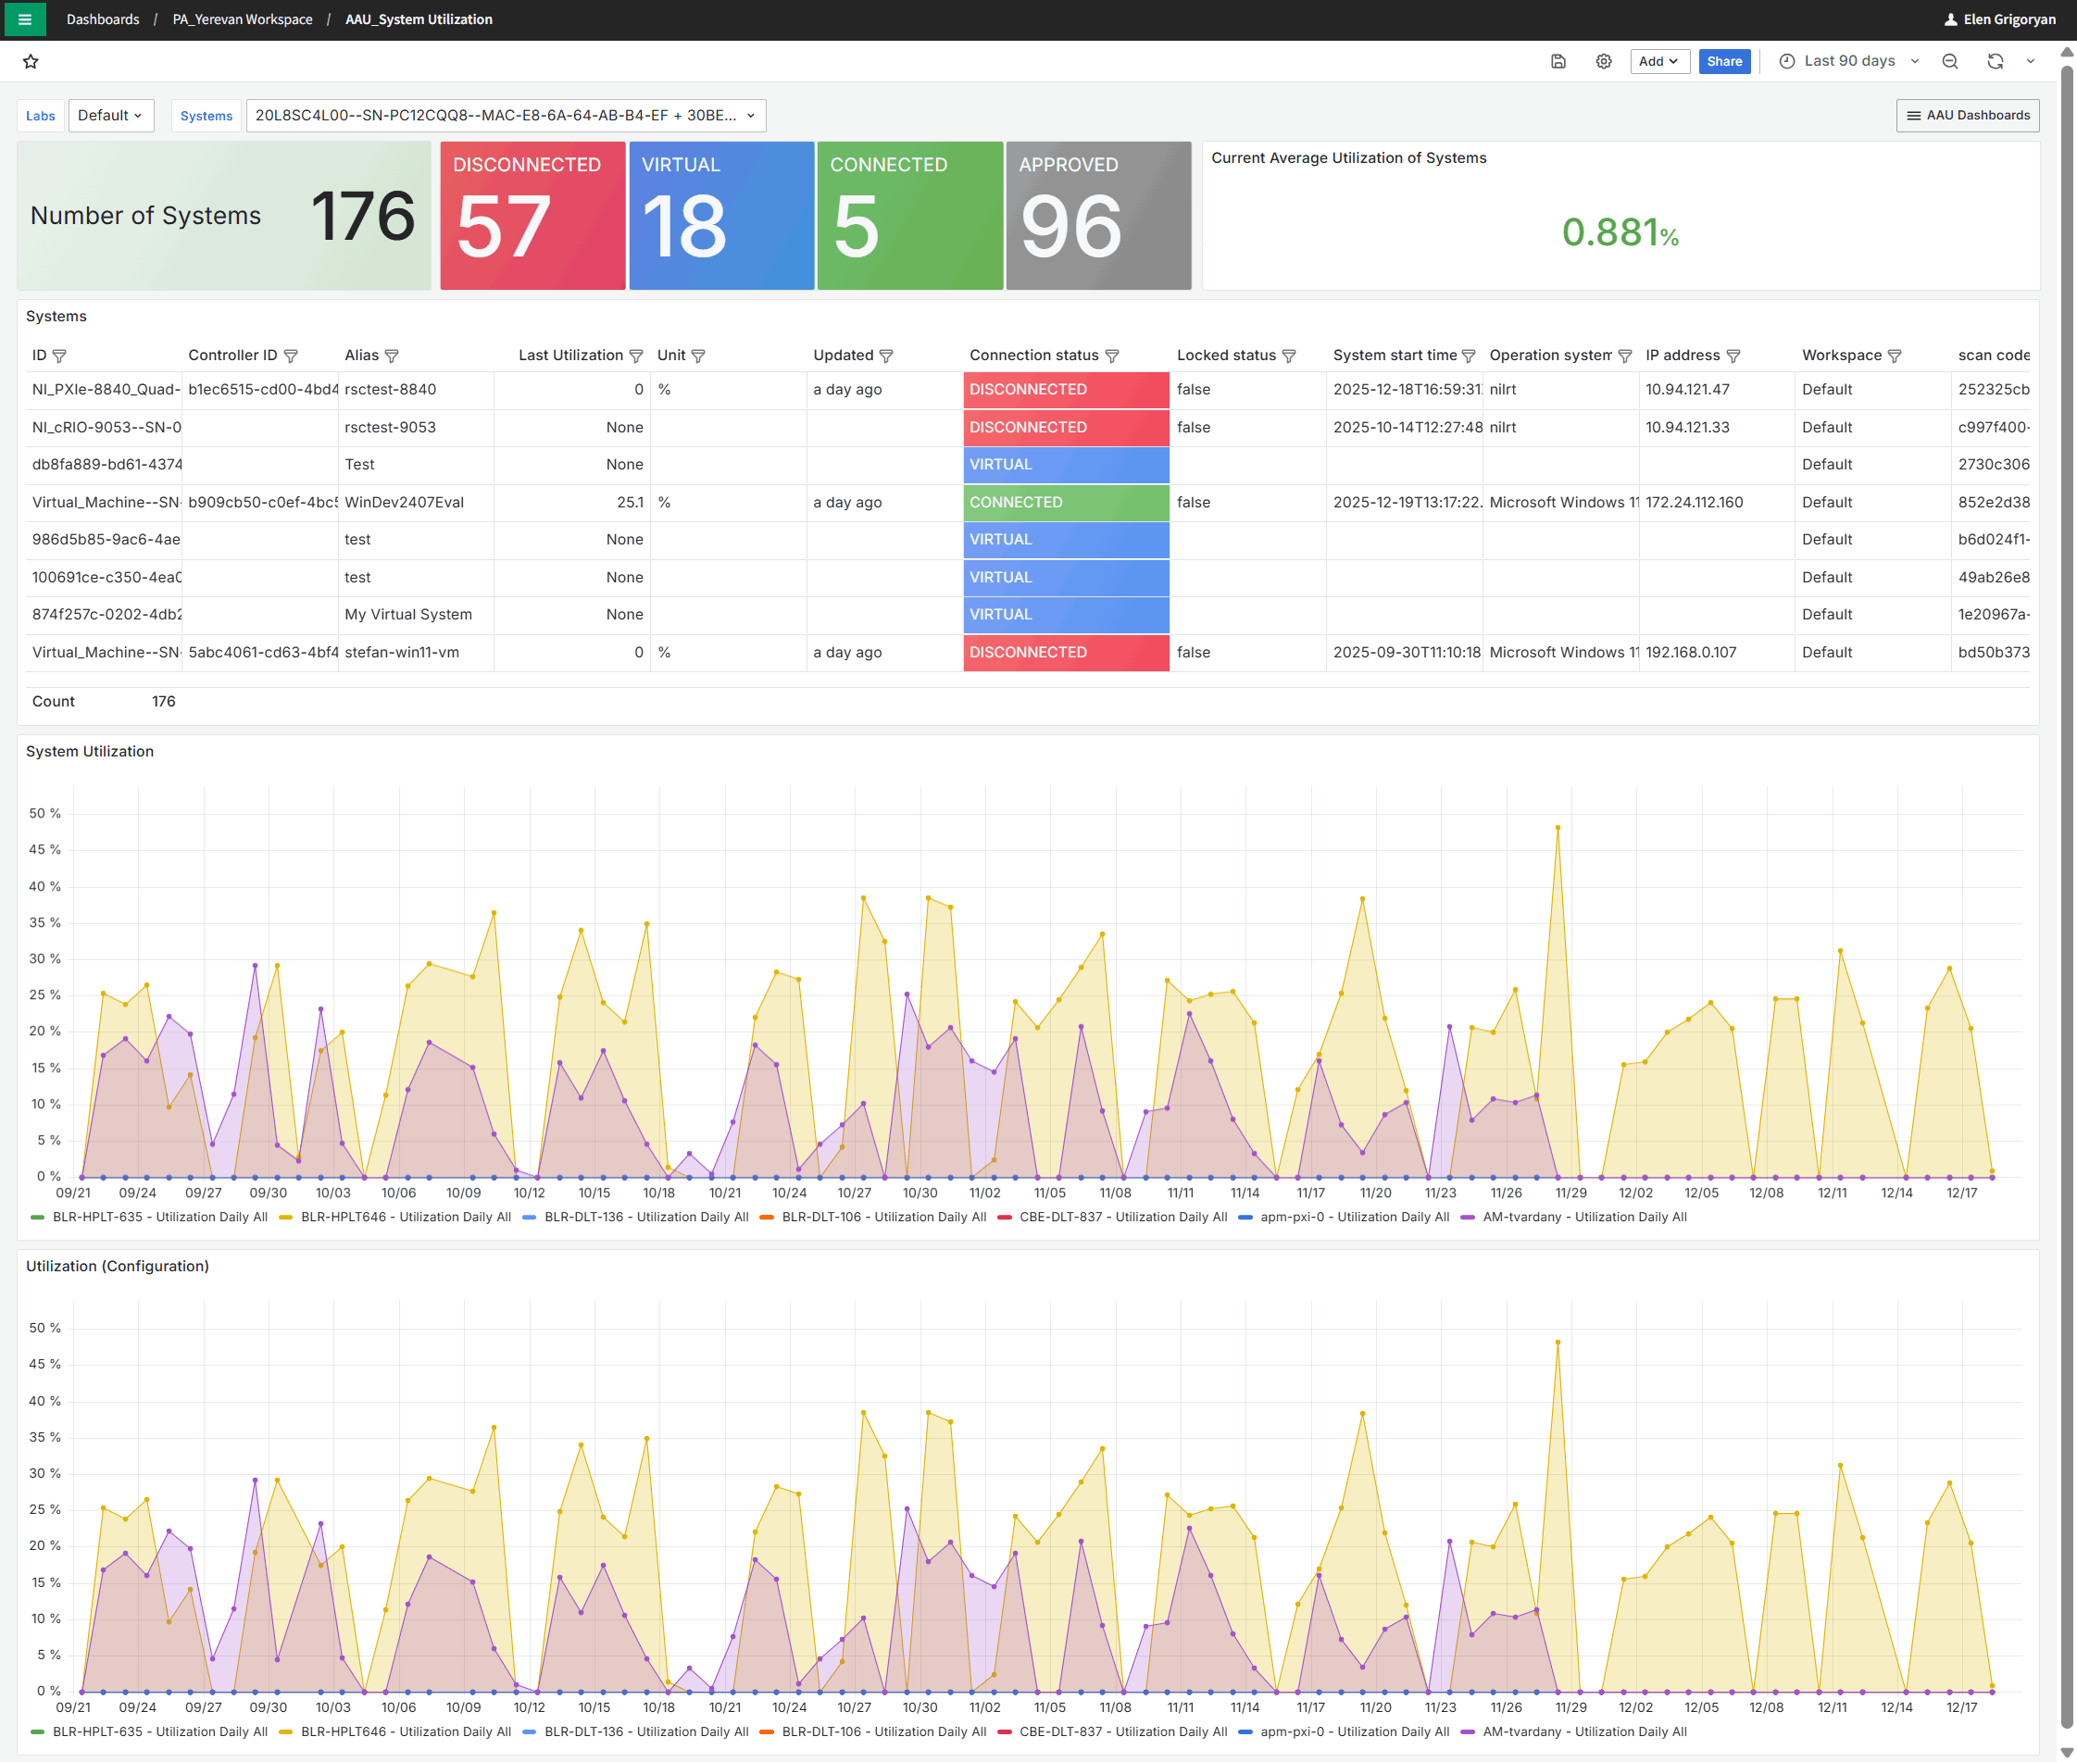
- Asset Utilization
  - The Asset Utilization dashboard provides functionality like the System Utilization dashboard but extends visibility to asset-level details within the selected system. This includes additional information such as calibration status. The dashboard presents high-level metrics along with two time-series charts that visualize utilization trends for the selected assets across predefined categories.
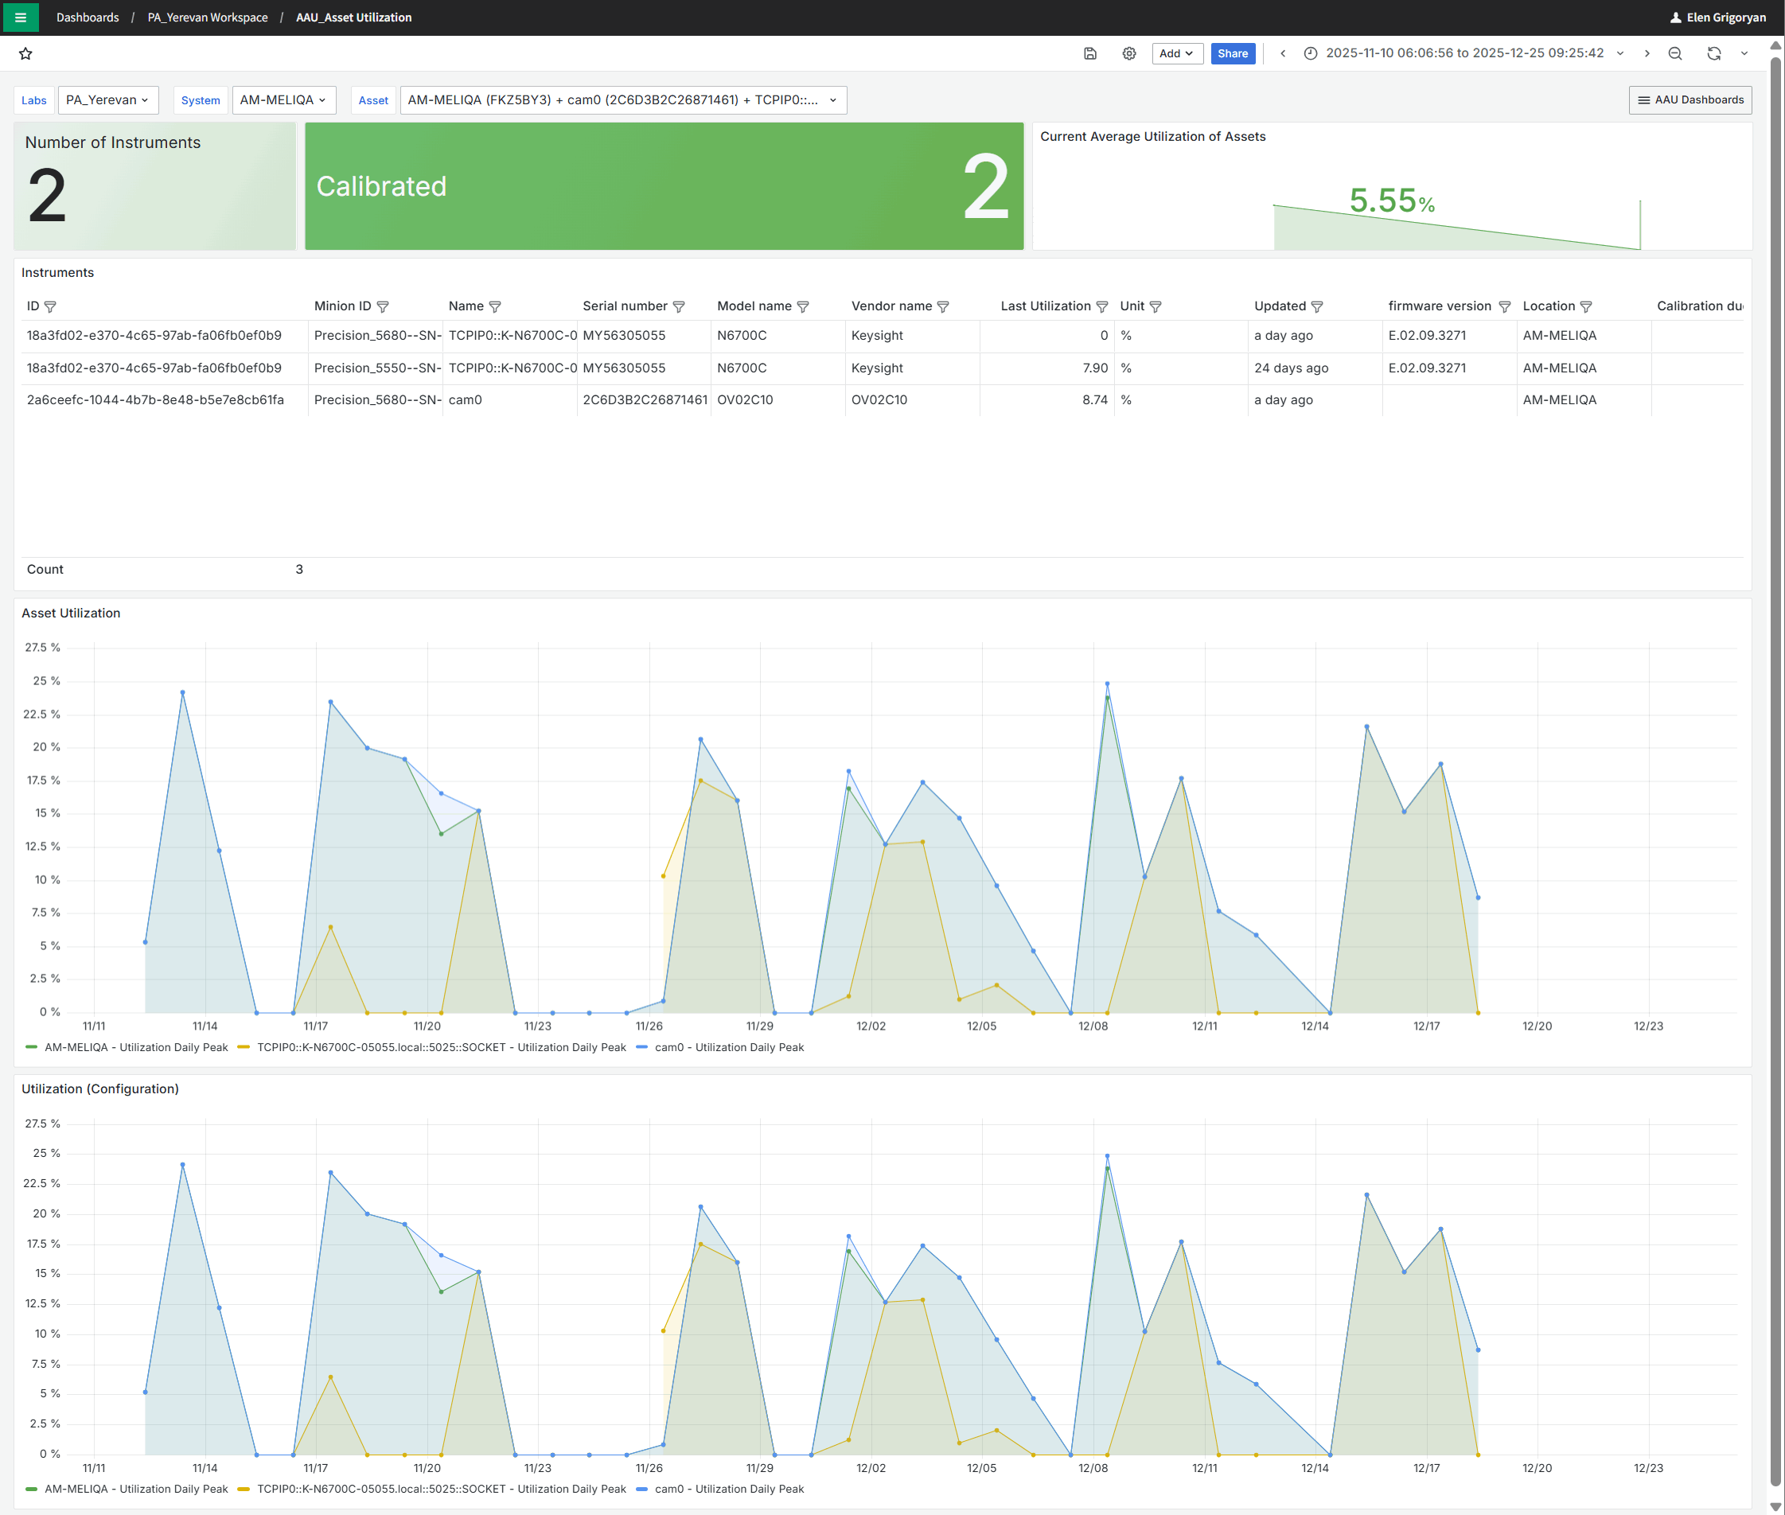

Step by step installation Instructions:
Solution installation and configuration information is provided with the below step by steps instructions.
Publishing the Notebook
- To import the Jupyter notebook into your SystemLink Enterprise open Automation >> Scripts from the SLE main menu, click the Upload Files button and select the Utilization to Tags SLE.ipynb notebook.
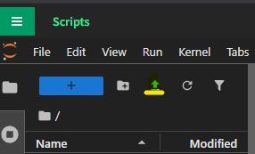
- Notebook has the following input parameters shown below.
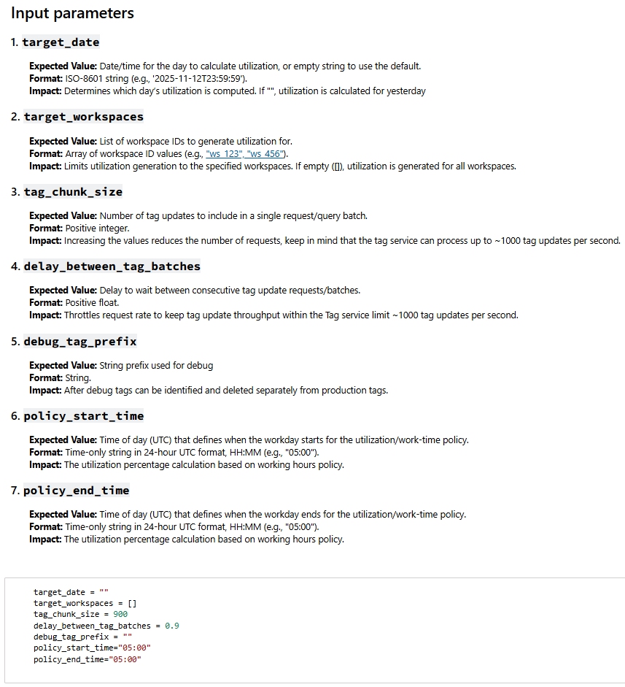
- Right click the notebook file and select Publish to Systemlink from the list.
- In the Publish Notebook window select the workspace where you want the notebook to be available.
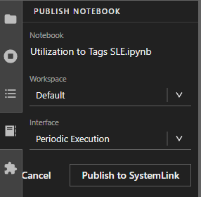
- From the Interface drop-down select Periodic Execution.
- Click Publish to SystemLink button.
After publishing the notebook to SLE, a confirmation popup will appear indicating the operation was successful. You can then proceed to configure the routine for scheduled execution.

Setting Up a Routine
- Open the SystemLink menu and navigate to Automation >> Routines.
- On the Routines page, click Create routine in the upper-left corner of the window.
- In the Create routine window under General section, provide the following details:
Figure 1 Create Routine panel
  - Routine name and Description
  - Workspace where the routine will run
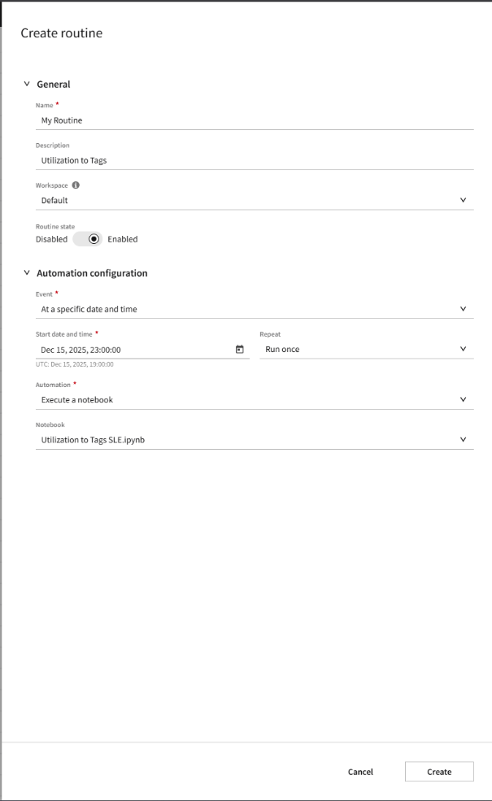
  - Ensure Routine State is enabled
- In Automation configuration section:
  - From the Event dropdown, select at a specific data and time.
  - Set the Start date and time. This determines when the notebook will run daily to update the tags.
  - Leave the Repeat field set to Run once.
  - In the Automation field leave Execute a notebook selected.
  - To select the notebook that should be executed in selected time every day, from the Notebook drop-down select the notebook you published earlier.
  - Click Create. Your routine will now appear in the table along with other routines.
- Go to Automation >> Execution page to monitor the status and the execution history of your notebook.
- After the notebook runs successfully at the scheduled time, tags will be generated for each system and asset. Navigate to Systems Management >> Systems, select a system and open the Tags tab for viewing tags associated with the system. You will see a new section of tags called Utilization. These tags will be updated every day with the single data point reporting daily utilization.
- Once all the steps are complete, you can import the dashboard to start viewing utilization data along with other system and asset-level information.
- If you need to start over and delete existing tags, use Delete Multiple Tags notebook provided in the same location. This will delete all tags so you can restart the process.
Importing the Dashboard
- First locate three .json files in the folder to be imported.
- From SLE main menu, go to Overview >> Dashboards.
- Click New in the upper-right corner and select Import.
- In the Import Dashboard window click Upload dashboard JSON file and select one of the three .json files to import the first dashboard.
- Change the name of the Dashboard if needed.
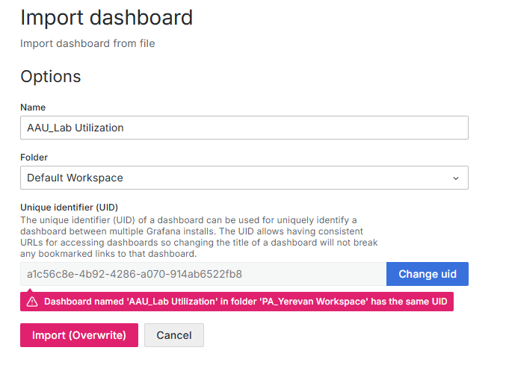
- Select the folder where you want to store the imported dashboard.
- Modify the UID to ensure uniqueness.
- Click Import. The newly imported dashboard will appear immediately, pre-configured and ready for use.
- Repeat the import process for the other two .json dashboard files until all three dashboards are successfully imported.

